STAFF RECORDS
Last Name ________________________
First Name ________________________
Role In Center ________________________; i.e., teacher, sub, bus driver, cook
Date of Birth ________________________
Social Security Number ________________________
Date of Hire ________________________ (or date re-hired __________________)
Criminal Record Check ________________________ (record date completed) Date submitted ____
Child Abuse and Neglect________________________ (record date completed) Date submitted ____
TB Skin Test ________________________ (record date checked/completed)
First Aid Certification ________________________ (expiration date)
CPR ________________________ (expiration date)
Work Schedule ________________________; i.e., Monday – Friday 9am-5pm
Date of Orientation ________________________
Date of Pediatric Abusive Head Trauma Training ______________________________
For Administrative Staff/Billing Persons Date of CCAP Training ________________________
Annual Training Hours ________________________ (total received for last full year worked – certificates or TRIS ok)
Education ________________________ (high school diploma, college, GED, CCCC)
Evaluation ____ (date of last annual evaluation)
Professional Development Plan _______ (date of annual plan)
Out of State Record Check ______________________ (date and source)
*Remember that all staff who have not lived in the state of Kentucky for 5 full years must obtain a criminal record check from each state of residence for the past 5 years.
*All Child Abuse and Neglect checks on new or returning staff must be submitted for approval within 5 days of hire. Keep a copy of the form that was submitted and note the date it was mailed.
*All Criminal Record Checks on new or returning staff must be submitted for approval on or before the first day of work. Keep a copy of the form that was submitted and note the date it was mailed.
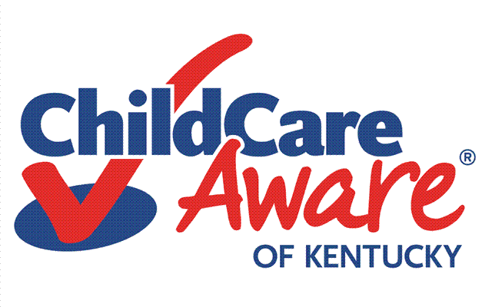 revised 9/20/14

