Tip Sheet for Providers for the
National Background Check Program (NBCP)

When you open your Kentucky Online Gateway (KOG) account, KARES should appear on your dashboard. This is the system being utilized for the National Background Check Program (NBCP).

Click on the KARES link. To enter an application into the system, you will click on the “Applications” tab (2nd tab from the left).

You will need to select “Application Forms”. Each applicant must complete the Waiver Agreement Statement (DCC-500); the Disclosure Form (DCC-501); and the Applicant Pre-Screening form. Please print these forms. The signed DCC-500 and DCC-501 are to be stored in the personnel records of the user and/or uploaded in the KARES web portal.

To add a new applicant, click on the “Applications” tab and then select “Add New” (1st selection in the drop-down box). You will be directed to search for an existing profile to ensure the person does not already exist in the system. You will search for the person using the Social Security Number (SSN) and Last Name or Date of Birth. The SSN and at least one of the identifiers is required.

If a match is not found, the system will display a not found message. Click the green “Add New Applicant” button in the lower right corner to create an Applicant Profile. Using the information contained on the Applicant Pre-Screening form, create a profile. All required fields are denoted with a red asterisk (*). Please make sure to enter ALL aliases and prior out-of-state addresses for the applicant. Failure to include this information is considered be making a false statement and is grounds for disqualification per federal regulation. After data entry is complete, you will click the green “Next” button in bottom right corner.

***If a data entry error is made (e.g. misspelled name, wrong date of birth, wrong Social Security number), please contact the DCC Helpdesk CHFSDCCNBCP@ky.gov or by calling 502-564-2524. A member of staff can edit the information.

If a match is found, the “Person Summary” screen will be displayed. To add an application for your center, please click on the green “Add New Application” button which is on the right above the “Personal and Demographic Information.”

***In the Race field, there are only 4 options listed (Asian or Pacific Islander; Black or African-American; American Indian or Alaska Native; White). These are the races that are acknowledged by the FBI. Please allow the applicant to choose which category they best fit.

***If the address listed on the ID differs from the address listed on the application, please enter the address listed on the ID as the permanent address. You can enter the other address as the mailing address. Most fingerprint sites will not scan the fingerprints if the application address and the address on the ID do not match. Examples would be college students who maintain their home state/county driver’s license but live on campus or military families who are stationed in KY but maintain their home state driver’s license.

***There is a new field “Starting in Month, Year”. This is to capture the timeframe the applicant has lived at the address listed. This was added to help DCC identify those who have lived out-of-state during the past 5 years to ensure all necessary interstate background checks are completed.

You are required to enter an email address for the applicant. IdentoGo, the new fingerprint vendor, sends an email to the applicant allowing them to schedule a fingerprint appointment.

You will then be directed to Pre-Employment Information screen. You must enter the information in the drop-down boxes in the order in which they are listed: Provider (name of provider/facility); Position Category (type of facility); Position; and Employee Type. Then click the green “Next” button in bottom right corner.

After the Pre-Employment page is complete, you will be asked to verify the applicant’s identity. A current picture ID is required. Preferred verification is a current driver’s license or identification card. There is a drop-down box allowing you to specify what type of identification you are accepting. In the Description section, you will need to enter the Issuing State/Authority, the Document Number (Driver’s License Number) and Expiration Date. A scanned copy of the form of identification must be uploaded to the KARES Web Portal.

***If you do not have a scanner, you could take a picture of the driver’s license or identification card with a smart phone, then text/email it to yourself. You could then save the picture to your desktop and then upload it by selecting “Upload Document”. You will then click on the green “Next” button in the bottom right corner.

You will then be directed to the Confirm Applicant Consent screen. This screen is asking you to confirm the applicant has given consent to have a background check completed and has been made aware of the process and terms. The DCC-500 (Waiver and Agreement form) and DCC-501(Disclosure form) as mentioned above fulfill this requirement. Placing a checkmark in both boxes is required before moving on with the application process.

The next screen is the Applicant: Research Registries screen. There are 3 registries that will be searched: two of the searches will be completed by you and one is an auto-search completed by the system.

The first registry listed is the Kentucky Sex Offender Registry. You must click on the link provided by the system. You will be directed to the Kentucky Sex Offender Registry page. You will search by the applicant’s last name. Scroll through the results to determine if your applicant/employee is listed. If the applicant’s/employee’s name does not appear on the registry, you will select “Cleared” on the Registry screen. If the applicant/employee does appear on the registry, you will select “Not Cleared.”

The next registry is the KY Child Abuse Network Registry. This is completed by an automatic matching feature that will indicate possible matches for abuse registry hits. If the results indicate no matches were found, you will select “Cleared.” If there are matches found, you will select “Not Cleared”. What does a “match” mean? This means the Cabinet has made a finding of abuse or neglect against the applicant and the applicant’s name appears on the Central Registry. If a person’s name is on the Central Registry, it will remain there for seven (7) years. The only way to have one’s name removed from the Central Registry is to request an administrative hearing through the Office of the Ombudsman, Quality Advancement Branch. You may click on the KY Child Abuse Network Registry link which will provide contact information for the Office of the Ombudsman. The applicant will need to contact the Quality Advancement section of that office to discuss the issue.

The last registry listed is the National Sex Offender Public Website. You must click on the link provided by the system. You will search by the applicant’s first and last name. Scroll through the results to determine if your applicant/employee is listed. If the applicant’s/employee’s name does not appear on the registry, you will select “Cleared” on the Registry screen. If the applicant/employee does appear on the registry, you will select “Not Cleared.”

If the registries have not been marked as “Cleared” or “Not Cleared” the process cannot move forward. When any of the registries are marked “Not Cleared”, the application will automatically be closed once the “Next” button is clicked.

The next screen will be the Payment screen. At this time, DCC is utilizing Coronavirus Response and Relief Supplemental Appropriations (CRRSA) Act funds to pay for the cost of background checks. You will see the following:
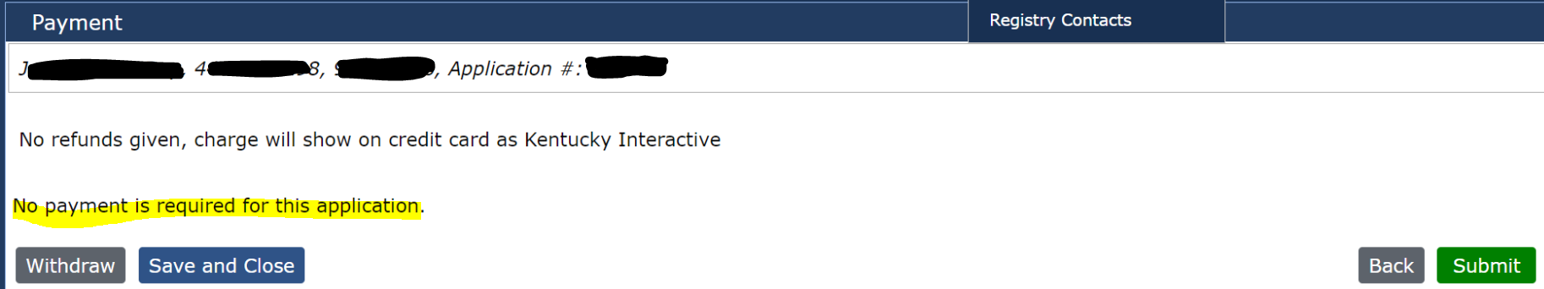

After payment is complete, select “Submit” and the Application Submission Confirmation page will be displayed.
You will no longer generate a “Live Scan Fingerprinting Form”. Instead, an email will be sent to the email address entered for the applicant. The email will appear in their inbox as:

The body of the email will have a link allowing the applicant to schedule an appointment:
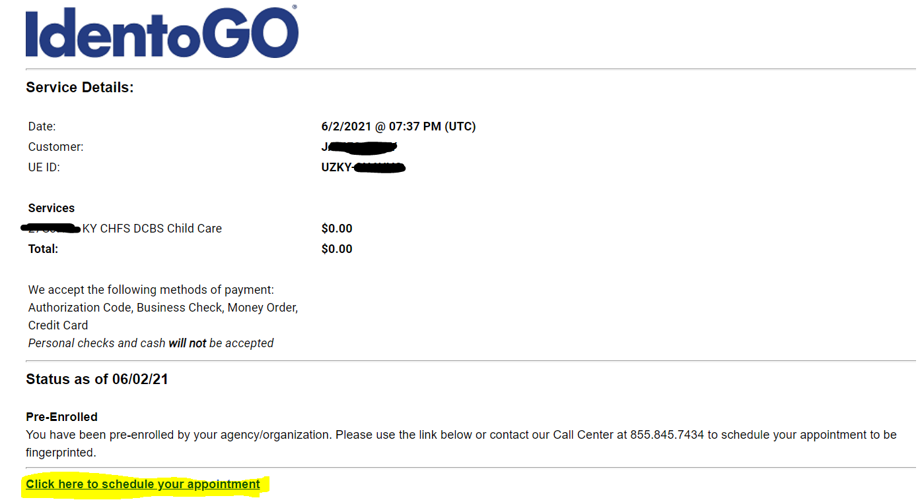

When the applicant clicks on the link they will be directed to the IdentoGo website. They will be required to enter demographic information (info you have already entered into KARES) to complete the registration process.

The applicant will be asked to enter a zip code to search for the nearest fingerprint location:

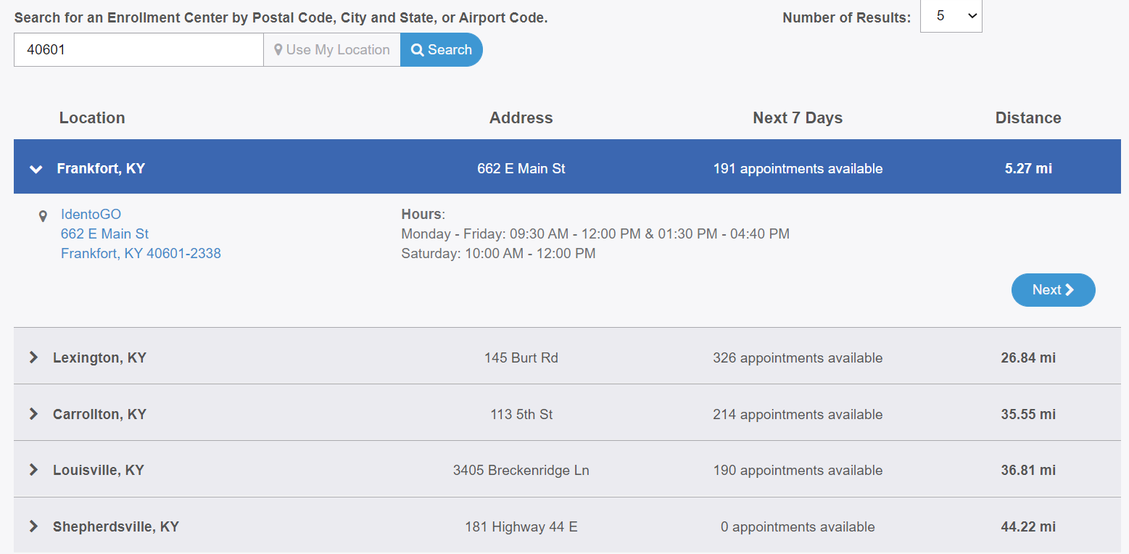
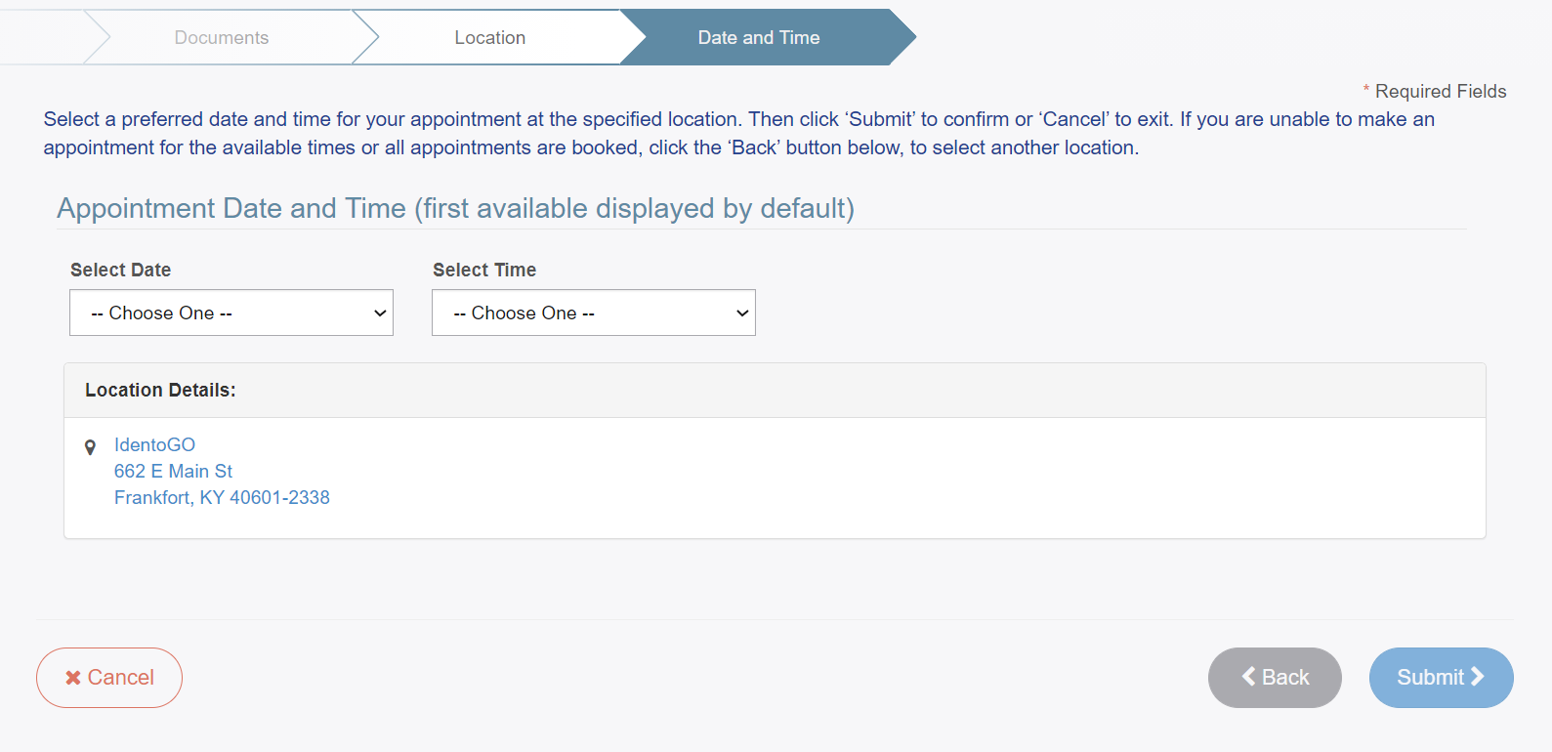

The applicant will then receive a confirmation email:
Once the fitness determination has been made, you will receive an email stating “Fitness Determination Available.” From the KARES home page, scroll down to the “At a Glance” section. Click on the blue number in the “Eligibility Determination Complete” line. This will take you to the “Applications: Determination Available” screen. If there is a blue “Hire” button for your applicant in the “Employment Status” column, please click on the “Hire” button and enter the determination date (this is the date the results were received). If there is no “Hire” button in the “Employment Status” column, verify the system shows the applicant as a permanent employee and then click “Close” under the “Actions” column on the far right-hand side of screen.

